Student Performance Prediction System

Project Id: AIML-4

Name : Kartikeya Arya (Team Leader)
Class Roll Number: 8
University Roll Number : 2028443
Section and Group: Q G1

Name : Aashish Singh
Class Roll Number: 20
University Roll Number : 2028606
Section and Group: Q G1

Name : Aayush Rawat
Class Roll Number: 21
University Roll Number : 2028608
Section and Group: Q G1

Agricultural Data Clustering and PCA Visualization System
Project Id: AIML-5
Machine Learning Based Unsupervised Clustering Project

Table of Contents
1. Problem Description
1.1 Dataset Description
1.2 Flow Diagram
2. Modules for Project Implementation
2.1 Modules Used
2.2 Platforms Used
3. Machine Learning Models Used
4. Evaluation Metrics Used
5. Results and Visualizations
6. Conclusion and Future Scope
7. References

1. Problem Description
The project focuses on analyzing agricultural data using machine learning techniques such as Feature Selection, Principal Component Analysis (PCA), and K-Means Clustering. The system identifies hidden patterns in agricultural features like rainfall, temperature, soil moisture, nitrogen, fertilizer usage, and crop diversity. The objective is to group similar agricultural conditions to support smart farming and yield analysis.

1.1 Dataset Description
The dataset contains 1050 records and 14 selected features. The features include Rainfall, Temperature, Soil Moisture, Soil pH, Nitrogen, Phosphorus, Irrigation, Crop Area, Fertilizer, Pesticide, Sunlight, Crop Diversity, Mechanization, and Yield Variance. The data was normalized before clustering.

1.2 Flow Diagram
Dataset Collection → Data Preprocessing → Feature Selection → PCA Visualization → Elbow Method → K-Means Clustering → Cluster Visualization → Evaluation

2. Modules for Project Implementation

2.1 Modules Used
- Pandas – Used for dataset loading and preprocessing.
- NumPy – Used for numerical operations.
- Matplotlib – Used for creating plots and visualizations.
- Seaborn – Used for advanced data visualization.
- Scikit-learn – Used for PCA, K-Means Clustering, and Silhouette Score.

2.2 Platforms Used
- Jupyter Notebook – Used for implementing and testing machine learning code.
- Python – Main programming language used for the project.
- Visual Studio Code – Used for editing and debugging.

3. Machine Learning Models Used
1. Principal Component Analysis (PCA): PCA reduces high-dimensional data into two principal components for visualization.
2. K-Means Clustering: K-Means groups similar data points into clusters based on feature similarity. The Elbow Method was used to determine the optimal number of clusters.

4. Evaluation Metrics Used
Silhouette Score was used to evaluate clustering quality.
Formula:
Silhouette Score = (b - a) / max(a, b)
Where:
a = Average intra-cluster distance
b = Average nearest-cluster distance
Calculated Silhouette Score: 0.245

5. Results and Visualizations
Fig.1 Correlation Heatmap
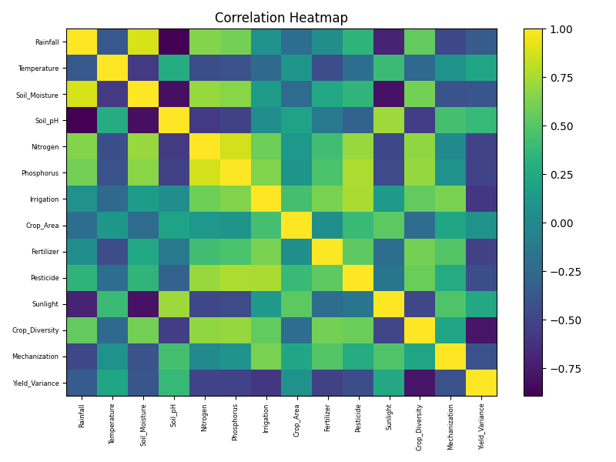
Fig.2 PCA Visualization
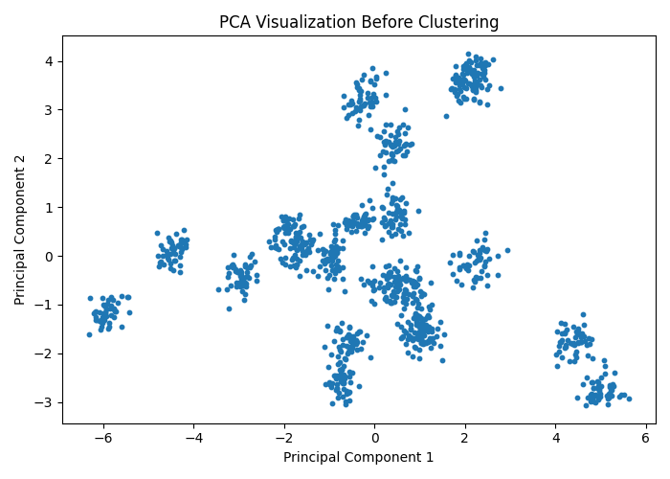
Fig.3 Elbow Method
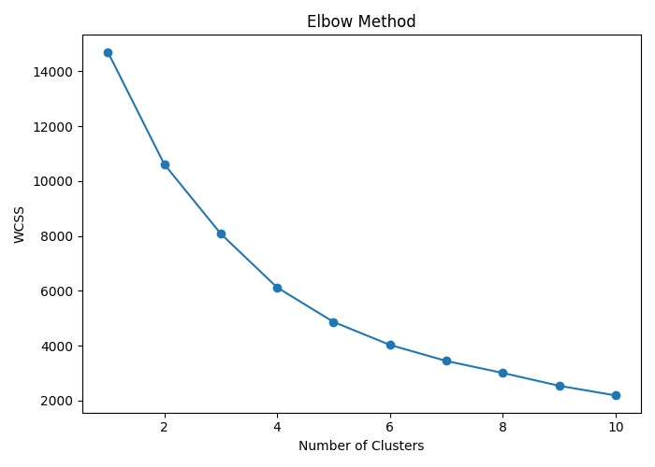
Fig.4 K-Means Clustering Result
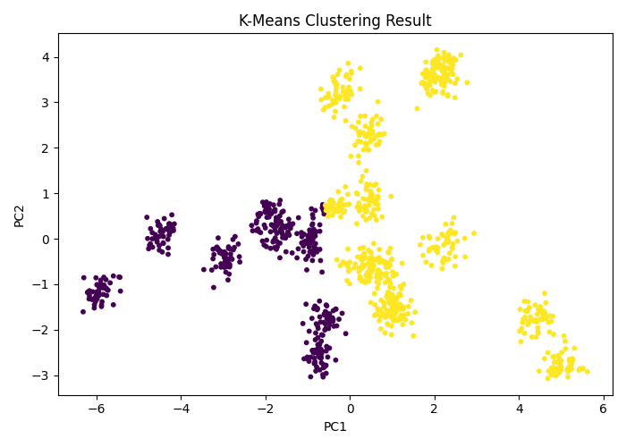

6. Conclusion and Future Scope
The project successfully applied PCA and K-Means clustering on agricultural data to identify hidden patterns and relationships among farming parameters. Future improvements may include real-time IoT integration, predictive analytics, and advanced clustering algorithms such as DBSCAN or Hierarchical Clustering.

7. References
- Scikit-learn Documentation – https://scikit-learn.org/
- Pandas Documentation – https://pandas.pydata.org/
- GeeksforGeeks – https://www.geeksforgeeks.org/
- Matplotlib Documentation – https://matplotlib.org/

